Final Data Analysis Project (COVID-19 Modified)
PSY 3713 Spring 2020
Student Name
Course Number
Final Project III

Final Data Analysis Project (COVID-19 Modified)

Introduction:
Black Mesa Research Facility is a fictional scientific research complex is tasked with an
assessing several research questions as directed by the manager. Being a hired psychological science researcher at this facility, I intent to analyze the data and compile a report. Data collection was done through artificial intelligence, GLaDOS, from several different experiments. These data are from experiments testing the effects of cake on subject obedience between men and women, levels of mental health concerns at another research center and the resistance capital, and measures about the Enrichment Center at Aperture Science. The research questions needed to be answered, as listed below.

Research Questions
1) Does the promise of cake and a person’s gender have any effect on subjects following orders during training simulations at the Enrichment Center? a. Following orders is represented as obedience measured as the total percent time subjects followed commands from GLaDOS.
2) Are the levels of anxiety, depression, and psychopathy different at Aperture Science, Black Mesa, or the Citadel? a. Anxiety is measured on a scale of 0-150 with higher scores indicating greater anxiety. b. Depression is measured on a scale of 0-200 with higher scores indicating greater depression. c. Psychopathy is measured on a scale of 0-10 with higher scores indicating greater psychopathy.
3) Do time spent in the Enrichment Center, level of GLaDOS hostility, and subject gullibility tell us anything about the subject’s feelings of depression when subjects find out the cake is a lie? a. Time is represented in hours. b. Hostility is measured on a scale of 1=docile to 10=homicidal. c. Gullibility is measured on a scale of 1-15 with higher scores indicating greater gullibility. Depression is measured on a scale of 0-100 with higher scores indicating greater depression.
To answer the above research questions, the following hypothesis was deduced:

Hypotheses:
From the research questions, we deduced the following hypotheses
1) Cake and gender together have effects on the percentage of obedience
2) Workplace environment predicts levels of anxiety, depression, and psychopathy
3) Enrichment center time, GLaDOS hostility, and gullibility predict depression

Section I: SPSS Analyses
1.
To test the first hypothesis that cake and gender have an impact on the levels of obedience I chose Output I PDF file.
The syntax used to generate this output is as follows;
UNIANOVA Obedience BY Cake Gender
/METHOD=SSTYPE(3)
/INTERCEPT=INCLUDE
/PLOT=PROFILE(Gender*Cake)
/EMMEANS=TABLES(OVERALL)
/EMMEANS=TABLES(Cake)
/EMMEANS=TABLES(Gender)
/EMMEANS=TABLES(Cake*Gender)
/PRINT=ETASQ DESCRIPTIVE HOMOGENEITY
/CRITERIA=ALPHA(.05)
/DESIGN=Cake Gender Cake*Gender.
Steps:
Go to Analyze > General Linea Model > Univariate > Transfer the response variable (Obedience) into the Dependent Variable box, >Transfer Gender and Cake into Fixed Factor(s) box,
>Click on Model > Click on Custom > Change the Build term Type to be Maine effects > Transfer both Gender and Cake into the model box,
> Change the Build term Type into interaction >
>Select both Gender and Cake and Transfer them into the model box
>Click Continue
>Click on Plots >Transfer Gender into the Horizontal Axis > Transfer Cake into the separate lines> Click Add > Click Continue
> Click on Options > Transfer (OVERALL), Gender, Cake and Gender*Cake into the Display Means for box> select Descriptive Statistics and Homogeneity Tests under Display>
>CLICK CONTINUE CLICK OKAY.
2.
Output E PDF file was used to test the hypothesis that the workplace environment predicts levels of anxiety, depression, and psychopathy.
The syntax used to generate the output in this PDF file was;
ONEWAY Depression Anxiety Psychopathy BY Workplace
/STATISTICS DESCRIPTIVES HOMOGENEITY BROWNFORSYTHE
/MISSING ANALYSIS
/POSTHOC=TUKEY ALPHA(0.05).
Steps
Go to Analyze > Compare Means >One-Way ANOVA > Transfer all the response variable into the dependent variable (Depression Anxiety Psychopathy) into the dependent list box
>Transfer the grouping variable (Workplace)into the Factor variable box
>Click on Post hoc > Select Tukey > Click Continue >
Click on Options > select Descriptives, Homogeneity of Variance Tests and brown for the
>Click Continue
3.
Output J PDF file contained the most appropriate analyses suitable for testing the hypothesis that time in enrichment center environment, the hostility of GLaDOS, and gullibility predicts the level of depression. The syntax used to generate this output was as follows:
REGRESSION
/MISSING LISTWISE
/STATISTICS COEFF OUTS R ANOVA ZPP
/CRITERIA=PIN(.05) POUT(.10)
/NO ORIGIN
/DEPENDENT Depressed
/METHOD=ENTER Time Hostility Gullibility
/SCATTERPLOT = (*ZRESID,*ZPRED)
/RESIDUALS HISTOGRAM(ZRESID) NORMPROB(ZRESID).
Steps:
Go to Analyze >Regression> Linear > Transfer the dependent variable (Depressed) into the dependent variable box > Transfer the three independent variables (Time Hostility Gullibility) into the independent variable box,
Click Statistics > Select Part and Partial Correlations Click Continue,
Click on Plots > Transfer *ZRESID into the Y-axis box *ZPRED into the X-axis box >Select Histogram and Normal Probability Plot. > Click Continue > Click Okay

Section II: Analytical Rationale
To Answer hypothesis 1, I chose Output I PDF files for a number of reasons. First, we are examining how two binary variables (cake and gender) may impact on a continuous variable outcome (which is following orders during training simulations measured as the total percent time subjects followed commands from GLaDOS). While the T-test may help in mean comparison of the percentage of obedience between categories in each of the binary variables, it may not be appropriate since we want to examine how both factors predict obedience and possibly a test of interaction between the two variables. Hence, I am the most appropriate since it incorporates both ANOVA and T-test unlike in L. Lastly, regression analysis as used in C may not be suitable since the two predictor variables are not continuous and thus may not meet the assumptions of classical linear regression analysis such as normality assumption.

To answer hypothesis 2, which holds that the Workplace environment predicts levels of anxiety, depression, and psychopathy, I chose the output E PDF file, which carries out one Way ANOVA. In this case, the workplace as the only predictor variable is categorical with more than two categories. The three predictor variables are measured on scale hence continuous. The Analysis of Variance (ANOVA) displayed in this output is suitable to test between-subjects-effects.

To answer hypothesis 3, Output J PDF is the most appropriate since the regression analysis has been employed to relate the variables in question. All the variables are continuous since time is measured in hours, and the rest is measured on the scale, as indicated in the research questions sections. The output indicates that time spent in the Enrichment Center, level of GLaDOS hostility, and subject gullibility are the predictors of levels of depression, which are in line with the third hypothesis.

Section III: Results

Hypothesis 1
One of the major assumptions that are testable in this test is the assumption of the equality of variance across the groups. Here, we use Levene’s test to test for this. Based on the output, the assumption of the equality of error variance of the dependent variable across the groups was violated at a 5% level of significance. (F_{3,90} =37.504, p-value < 0 .05) as shown in table 1 below.
Table 1
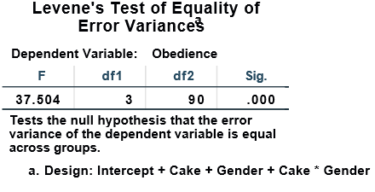
Flexing the assumption, we first examine the descriptive statistics.

Table 2
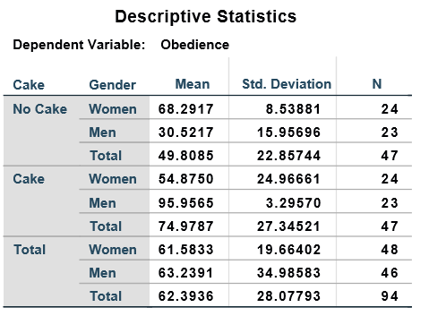
Table 2 shows the distribution of means of the percentage of obedience by gender and by gender within the promise of a cake. To test whether two variables affect obedience, we statistically tested the hypotheses using the results in the ANOVA table below. From table 3, the promise of a cake, and gender explains 70.2% of the variation in the percentage of obedience. (R-Square 0.702).

Table 3: ANOVA
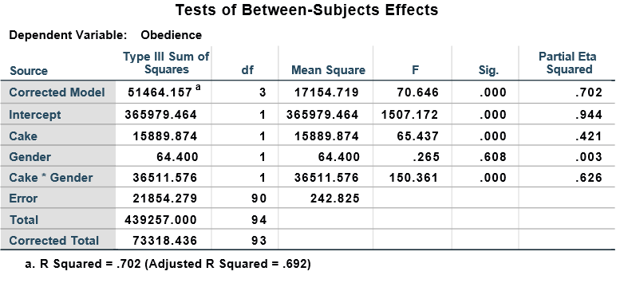
The results indicate that we are 95% confident that the promise of cake has a statistically significant effect on the percentage of obedience$(F =65.4, P-Value<0.05)$. As shown in table 4, those who kept their promise had a higher mean score of obedience $(μ=75.4, SE=2.27)$ as compared to those who did not $(μ=49.4, SE=2.27)$.
Table 4
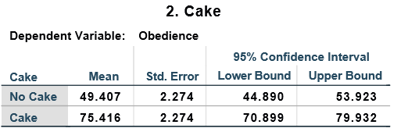
On the other hand, gender seems not to have a significant effect on the percentage of obedience at a 5% level of significance $(F =0.27, P.Value>0.05)$. As shown in table 5, the mean scores of obedience for the two are approximately equal (male; $μ=61.6, SE=2.25,$ female, $μ=63.2, SE=2.30)$.
Table 5: Descriptives by Gender
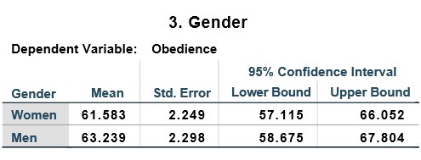
The results further indicate that there is a statistically significant interaction effect of both promise of a cake and gender in the determination percentage of obedience at a 5% level of significance $(F =150.4, P.Value<0.05)$. As shown in table 6, the mean scores of obedience of women who kept their promise lower mean score (women; $μ=54.9, SE=3.18)$as compared to their male counterparts ($male; μ=96.0, SE=3.25)$.
Table 6: Descriptives by Gender and Cake
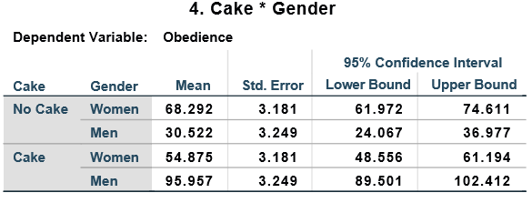
This indicates that both variables better explain the determination of the tendency to follow orders during training simulations at the Enrichment Center. The overall implication is that men who keep their promises are more likely to be obedient, as illustrate by the following profile line chart in figure 1.

Figure 1: Profile Line Chart
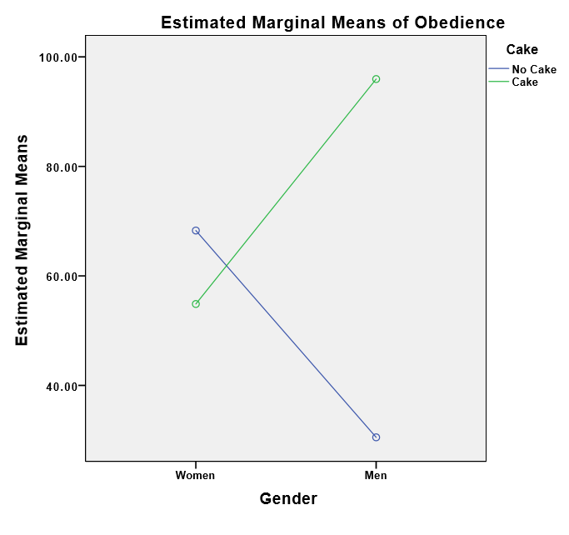

Hypothesis 2
From table 7, the assumption of the equality of error variance of the dependent variable across the groups has only been violated in the variable Psychopathy $(F_{2,37}=2.47, P.value>0.05)$. The other two variables meet the assumption $(P.values<0.05)$.
Table 7
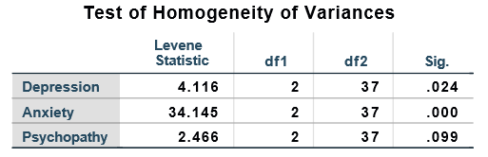
Flexing the assumptions, we proceed with the following analysis.
Table 8
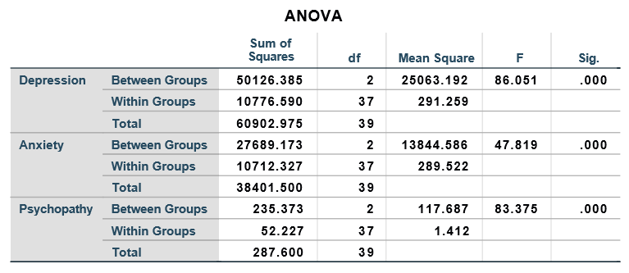
The ANOVA analysis indicates that the average levels of depression do not significantly vary at different workplaces, namely; Aperture Science, Black Mesa, and the Citadel. $(F_{2,37}=86.1, p.value<0.05$).
Similarly, the ANOVA analysis indicates that the average levels of anxiety do not significantly vary across workplaces, namely; Aperture Science, Black Mesa, and The Citadel $(F_{2,37}=41.8, p.value<0.05$). The average levels of psychopathy were also found not to significantly vary at different workplaces, namely; Aperture Science, Black Mesa, and The Citadel $(F_{2,37}=83.37, p.value<0.05$).
From these results, there is no need for conducting the post hoc tests.

Hypothesis 3
Since classical linear regression analysis is employed in this section, we test the following assumptions regarding the assumptions of classical linear regression analysis.
Normality Assumption
We examine whether the residuals are normally distributed using the histogram below.
Figure 2
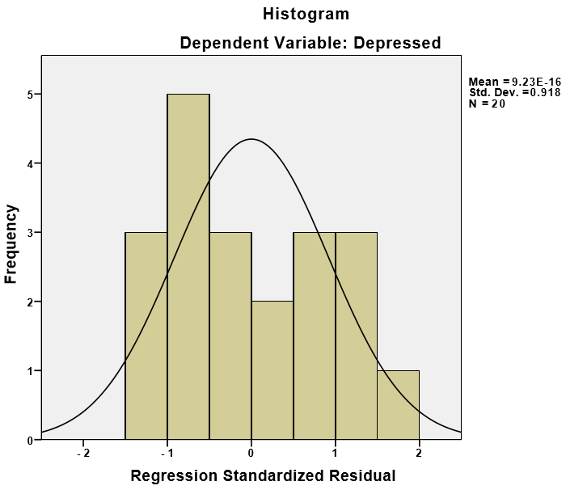
Figure two indicates that the residuals are approximately normally distributed as shown by the fitted density plot; hence the assumption of normality has been met.

Control
We examined the part, and partial correlations in this study and the results are as presented below;
Table 9
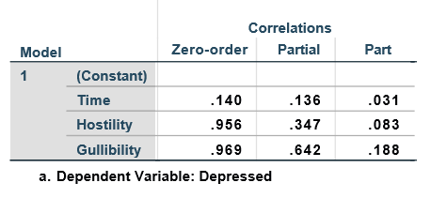
None of the variables has been used in this study as control variables.
Homoscedasticity
The residual plot in figure 3 shows the residuals are randomly and evenly distributed. This indicates that the assumption of homoscedasticity has been met.
Figure 3
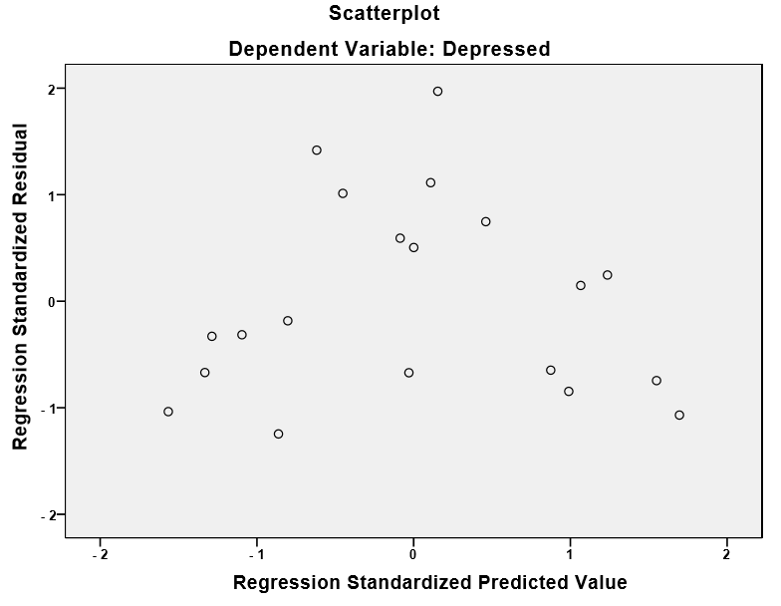Table 10: Model Summary
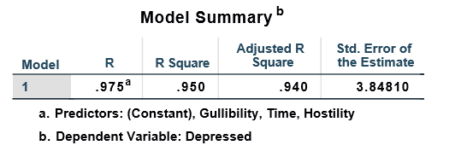
Table 10 shows that Enrichment center time, GLaDOS hostility, and gullibility explains 97.5% of the variation in the levels of depression (R-Square = 0.975).

Table 11: Model fit
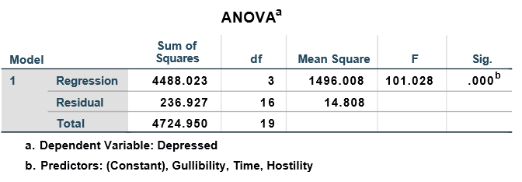
From table 11, the overall model was found to be a good fit at a 5% level of significance. $(F_{3,16}=101.028, p-value<0.05)$.
Table 12
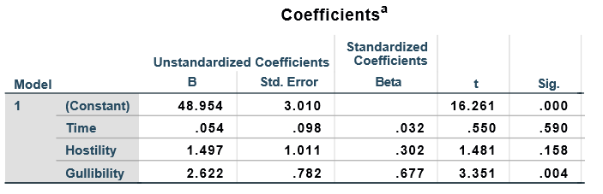
From table 12, we can deduce the following model;
$$Depression=48.95+0.05TIME+1.50 Hostility+2.62Gullibility$$
Gullibility is the only variable that has a significant positive effect on feelings of depression $(t=0.68, p.value<0.05)$. Time and hostility, on the other hand, have an insufficient effect on levels of feelings of depression when subjects find out the cake is a lie. (p-value <0.05)

References
Field, A. (2009). Discovering Statistics Using SPSS, Third Edition.
Field, A. (2013). Discovering statistics using IBM SPSS statistics. sage.
Hui, E. G. M. (2019). Inferential Statistics and Regressions. Learn R for Applied Statistics (pp. 173-236). Apress, Berkeley, CA.
Rashid, I. (2016). Using SPSS: An Interactive Hands-on Approach. South Asian Journal of Management, 23(3), 214.
Schützenmeister, A., Jensen, U., & Piepho, H. P. (2012). Checking normality and homoscedasticity in the general linear model using diagnostic plots. Communications in Statistics-Simulation and Computation, 41(2), 141-154.

